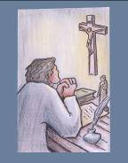
18. EVENT: The writing of the
Treatise on True Devotion
● Date : 1712 ??
● Place : Hermitage of St-Éloi
● Value : Consecration to Jesus through Mary, lived and proposed by Montfort
● The Story :
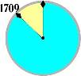
In his treatise on True Devotion to the Blessed Virgin, Montfort takes up again the idea he had sketched with broad strokes in chapter XVII of The Love of Eternal Wisdom: the Blessed Virgin as a means of acquiring Wisdom. The True Devotion to the Blessed Virgin is the full flowering of this fundamental thought.
In the absence of precise information, we are reduced to conjecture regarding the place and the date of its composition, which was certainly quite late on, for Montfort says clearly that in it he has written down what he had been teaching in all his missions “for many years” (TD 110). It seems very likely that this was in the hermitage of St-Éloi (La Rochelle), in the Autumn of 1712. The composition was done relatively quickly. Abundant reading, familiar conversations with the holiest and wisest persons of his time, unceasing preaching, ardent prayer “over many years” (TD 113): such was, according to the author himself, the preparation for this little book. He undertakes it with enthusiasm: “My heart has dictated with special joy all that I have written” (no. 13). As Montfort had predicted (TD 114), this little book was lost “in the darkness and silence of a chest” and was not re-discovered until 1842. The first pages of the manuscripts having disappeared, it was given the title we are familiar with. Montfort seems to suggest another title in number 227: “Preparation for the Reign of Jesus Christ”. We know the success it has had since that time. Pope John Paul II revealed it to a yet wider readership by making it the foundation of his own spiritual life.
● From Montfort’s Writings: (TD 120, 152)
As all perfection consists in our being conformed, united and consecrated to Jesus it naturally follows that the most perfect of all devotions is that which conforms, unites, and consecrates us most completely to Jesus. Now of all God's creatures Mary is the most conformed to Jesus. It therefore follows that, of all devotions, devotion to her makes for the most effective consecration and conformity to him. The more one is consecrated to Mary, the more one is consecrated to Jesus.
This devotion is a smooth, short, perfect and sure way of attaining union with our Lord, in which Christian perfection consists.
● Light from the Bible: (Luke 1:26-38)
In the sixth month the angel Gabriel was sent by God to a town in Galilee called Nazareth, to a virgin betrothed to a man named Joseph, of the House of David; and the virgin's name was Mary. He went in and said to her, 'Rejoice, you who enjoy God's favour! The Lord is with you.' She was deeply disturbed by these words and asked herself what this greeting could mean, but the angel said to her, 'Mary, do not be afraid; you have won God's favour. Look! You are to conceive in your womb and bear a son, and you must name him Jesus. He will be great and will be called Son of the Most High. The Lord God will give him the throne of his ancestor David; he will rule over the House of Jacob forever and his reign will have no end.' Mary said to the angel, 'But how can this come about, since I have no knowledge of man?' The angel answered, 'The Holy Spirit will come upon you, and the power of the Most High will cover you with its shadow. And so the child will be holy and will be called Son of God. And I tell you this too: your cousin Elizabeth also, in her old age, has conceived a son, and she whom people called barren is now in her sixth month, for nothing is impossible to God.' Mary said, 'You see before you the Lord's servant, let it happen to me as you have said.' And the angel left her.
● Personal integration/sharing
- What has most helped me to discover the role of Mary in my relationship with Christ?
- What passage from the Gospel concerning Mary speaks to me most?
- If I had to give a ‘title’ to Mary describing her role in my life, what would it be?
- What stages have I experienced in my relationship to Mary?
● Prayer/Celebration
Let us turn to Mary to tell her of the joy of having her as a companion on the way and the mother of our faith.
Hail Mary, full of grace.
- You are the one in whom the whole faith of the people of Israel comes to flower.
Hail Mary, full of grace.
- You are the fruitful earth in which the Father sowed his Word.
Hail Mary, full of grace.
- You are the docile clay in which the Spirit forms the body of the Son of God.
Hail Mary, full of grace.
- You are the most holy one through whom the whole human race welcomes its Lord.
Hail Mary, full of grace.
- In your arms, the shepherds discover the Saviour who is the friend of the poor.
Hail Mary, full of grace.
- In your arms, the nations discover the King who comes to serve.
Hail Mary, full of grace.
- Thanks to your faith, the new wine of the latter times is poured forth for us.
Hail Mary, full of grace.
- Your hope keeps you standing at the foot of the cross.
Hail Mary, full of grace.
- You are Mother of the Church, the Body of Christ in our world.
Hail Mary, full of grace.
- In you, the human race has entered into the glory of God.
Hail Mary, full of grace.
● Symbol: A manuscript page of True Devotion.
● Commitment
- Take the time to read a few chapters of True Devotion. Then share with others.
- Ask Montfort to help me to deepen my relationship to Mary.
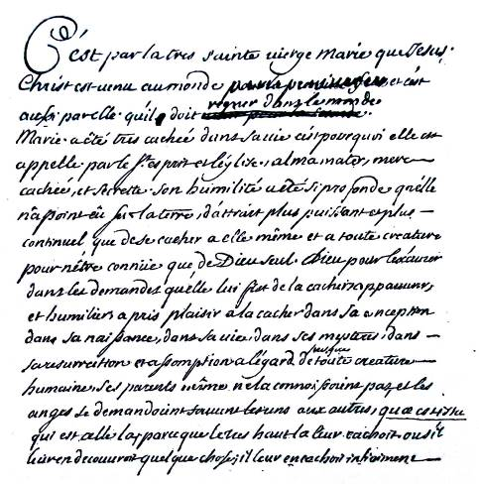
First page of the manuscript of the Treatise on True Devotion

