Prayer for the Opening of the Montfortian General Chapter
1st May 2017

Pilgrims without frontiers

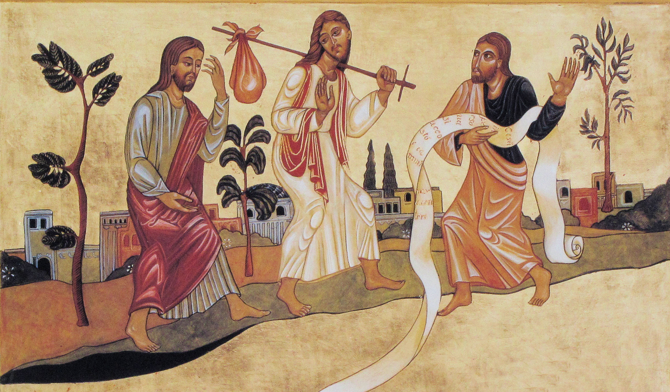

Hymn: suggestions: Christ be Our Light or Gather and Remember (Finlandia)
✵ Christ, be our light!
Shine in our hearts,
Shine through the darkness.
Christ, be our light!
Shine in your Church gathered to-day.

Opening Prayer (PM 1,4)
Let us pray to God our Father with the words of Montfort:
Memento Domine... Remember, Lord this Congregation which you have possessed from all eternity. Almighty God, by the power of your right arm which has lost nothing of its strength, make it a living reality. God of all goodness, remember your mercy of times past, and, in that same mercy, be ever mindful of this Congregation.
We ask you this through Christ your beloved Son, Eternal and Incarnate Wisdom
Amen
1. Jesus meets up with his disciples
The Gospel according to Saint Luke (24: 13-35; Acts 1:8)
 On Easter day, two of the disciples were on their way to a village called Emmaus, two hours walk from Jerusalem, and they were talking together about all that had happened. And it happened that as they were talking together and discussing it, Jesus himself came up and walked by their side.

Prayer
– That our brothers capitulant share their life experiences in mutual trust,
Lord, we pray you.
– That they share their deceptions and their fears regarding the future,
Lord, we pray you.
– That they may listen to each other with respect and openess,
Lord, we pray you.

✵ Christ, be our light!
Shine in our hearts,
Shine through the darkness.
Christ, be our light!
Shine in your Church gathered to-day.

2. Jesus walks with them
 But the disciples’ eyes were prevented from recognising him. He said to them, 'What are all these things that you are discussing as you walk along?' They stopped, their faces downcast. Then one of them, called Cleopas, answered him, 'You must be the only person staying in Jerusalem who does not know the things that have been happening there these last few days.' He asked, 'What things?' They answered, 'All about Jesus of Nazareth, who showed himself a prophet powerful in action and speech before God and the whole people; and how our chief priests and our leaders handed him over to be sentenced to death, and had him crucified. Our own hope had been that he would be the one to set Israel free. Three days have now gone by since it all happened.

Prayer
– That together we can welcome in a better way the Mystery of the Cross,
Lord, we pray you.
– So that through our difficulties and failures we grow nearer each other,
Lord, we pray you.
– So that experiences of leaving and dying in our personal history lead us to a renewed life,
Lord, we pray you.

✵ Christ, be our light!
Shine in our hearts,
Shine through the darkness.
Christ, be our light!
Shine in your Church gathered to-day.

3. He feeds them His Word and His Bread
 Then he said to them, 'You foolish men! So slow to believe all that the prophets have said! Was it not necessary that the Christ should suffer before entering into his glory?' Then, starting with Moses and going through all the prophets, he explained to them the passages throughout the scriptures that were about himself. When they drew near to the village to which they were going, he made as if to go on; but they pressed him to stay with them saying, 'It is nearly evening, and the day is almost over.' So he went in to stay with them. Now while he was with them at table, he took the bread and said the blessing; then he broke it and handed it to them. And their eyes were opened and they recognised him; but he had vanished from their sight. Then they said to each other, 'Did not our hearts burn within us as he talked to us on the road and explained the Scriptures to us?'

Prayer
– That we be thirsty of your Word,
Lord, we pray you.
– That it be our daily bread,
Lord, we pray you.
– That it be the light on our path,
Lord, we pray you.
– That it be the joy of our hearts,
Lord, we pray you.
– That your Bread shared together be the source of our unity,
Lord, we pray you.

✵ Christ, be our light!
Shine in our hearts,
Shine through the darkness.
Christ, be our light!
Shine in your Church gathered to-day.

4. He sends them on a mission
 That instant, the two disciples set out and returned to Jerusalem. There they found the Eleven assembled together with their companions, who said to them, 'The Lord has indeed risen and has appeared to Simon.' Then they told their story of what had happened on the road and how they had recognised him at the breaking of bread. (…) Forty days later, Jesus told them : "You will receive the power of the Holy Spirit which will come on you, and then you will be my witnesses not only in Jerusalem but throughout Judaea and Samaria, and indeed to earth's remotest end."

Prayer
– That this Chapter renew our missionary zeal,
Lord, we pray you.
– That this Chapter fill us with Montfort’s pastoral creativity,
Lord, we pray you.
– That this Chapter be for all of us a renewed Pentecost,
Lord, we pray you.
– That this Chapter be a source of hope for all Montfortian Entities,
Lord, we pray you.

Prayer for the General Chapter

Father,
Remember your Congregation
at this time of our General Chapter...
(Moment of silence)
You inspired Saint Louis Marie
to undertake the apostolic mission
of preaching the Gospel of Christ your Son to all people.
Aided by his prayers and taught by the Virgin Mary,
grant that we may be more and more open
to the inspiration of your Spirit,
attentive to the cries of the poor,
and so become untiring messengers of your Reign.
We make our prayer through our Lord Jesus Christ your Son,
who lives and reigns with you and the Holy Spirit,
one God, forever and ever. Amen.

Final hymn

✵ Christ, be our light!
Shine in our hearts,
Shine through the darkness.
Christ, be our light!
Shine in your Church gathered to-day.

