25 March 2017
« The Annunciation »

4th Celebration for the Preparation
of the General Chapter 2017

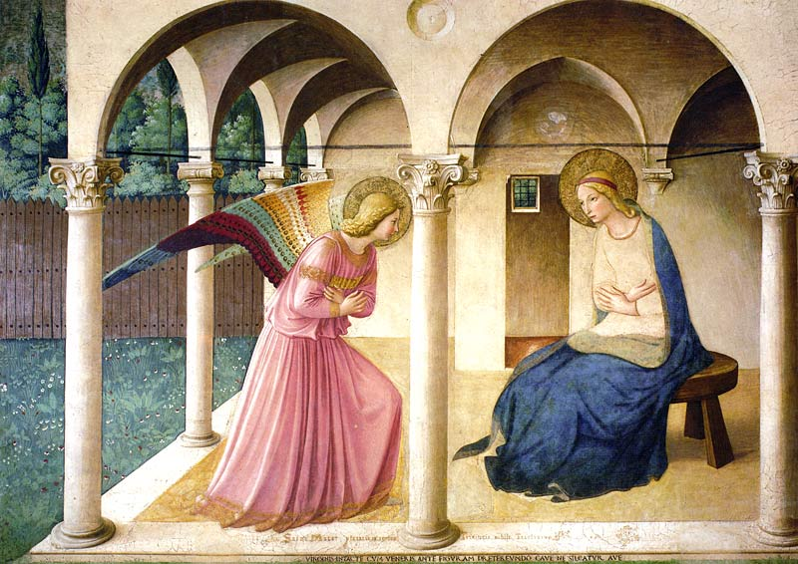

† This celebration is visually structured around a fresco of Fra Angelico representing the Annunciation. A series of six images have been prepared to this end and are available on our website <www.montfortian.info/chapitre-2017.html>, either individually or grouped in a powerpoint. The first image “01-angelico-complet.jpg” should be visible at the start of the celebration. If you have limited technical resources, only the first of the images could be projected, or participants can be referred to the reproductions inserted in the document.

 Entrance Hymn

1. Holy Virgin, by God’s decree,
you were called eternally
That he could give his Son to our race,
Mary, we praise you, hail full of grace. R.

R. Ave, ave, ave Maria!

2. By your faith and loving accord,
As the hand maid of the Lord,
You undertook God’s plan to embrace.
Mary, we thank you: hail full of grace. R.

Prayer

O Jesus living in Mary,
Come to live in me:
Your power in my weakness
Your love in my selfishness
Your Spirit in my heaviness
Your constancy in my fickleness
Your truth in my falsehood.
Come and grow in me
as you grew in Mary.
Come into the world through me
as you came into the world through her:
in the power of the Spirit,
for the happiness of humankind,
and for the Glory of the Father. Amen

Word of Introduction by the animator

Dear confreres, Father de Montfort tells us that «the great mystery of the Incarnation of the Word, on 25 March, is the proper mystery» of the spiritual process he proposes (TD 243). To deepen that mystery, we will explore a fresco created by Fra Angelico representing the Annunciation. Elements of this fresco will help us in centring our prayer on the four types of relation that constitute us and are presented in the lineamenta.

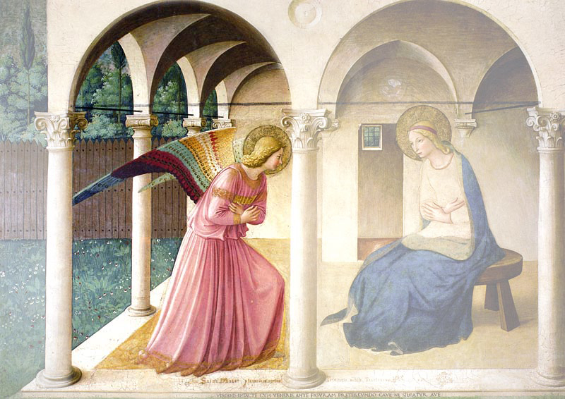

I. RELATION TO GOD

† The image “02-angelico-ange-angel.jpg” is projected.

Presentation
Animator:
The angel represents the world of God. Through him, God himself is knocking at the door of the human race. Will he find a human being whose love is so deep, whose faith is so entire that it will surround totally to God? Yes, God is the poor knocking at our door. The three arches above the angel refer to the three persons of the Trinity. At the bottom of the fresco, it is written in Latin «Mary is the noble abode of the entire Trinity».

Montfort speaks to us
From Love of Eternal Wisdom (64-65)
The bond of friendship between eternal Wisdom and man is so close as to be beyond our understanding. Wisdom is for man and man is for Wisdom. Wisdom's friendship for man arises from the fact that he is, in Wisdom’s creation, an abridgement of his marvels, his small and great world, his living image. Since Wisdom took the likeness of man by becoming man, and gave himself up to death to save man, he loves man as a brother and a friend. This eternal beauty is so intent on winning man's friendship that for this very purpose he has written a book. In it, he expresses such ardent desires for the heart of man, such loving invitations and promises, that you would say he needs man to be happy.

From the Lineamenta
From all eternity, God has wanted and called us in His Beloved Son. Through baptism, we were "plunged" in this Trinitarian relation to grow in it every day. As Montfortians, we want to consecrate all that we are to God by consecrating ourselves to Mary, who perfectly welcomed God in our flesh.
“Lord, what am I asking you for? Slaves of your love and of your will, men according to your heart, true children of your Holy Mother” (PM 8-10). One with Christ through our baptism, we want to grow every day in our relation with God our Father, in the joy and faith of Mary, “Mother of the divine Saviour, the most generous of the disciples of the Lord” (LG 61).
There lies the meaning and foundation of our whole existence.

Prayer

Animator: Through the words of Montfort in Hymn 103, let us unite to his ardent desire of Wisdom.

Together:

Jesus, uncreated Wisdom, Come to me.
Jesus, incarnate Wisdom, Come to me,

O Word, equal to the Father, Come to me.
Light of light, Come to me.

Your folly is wisdom, Come to me.
Your penury is plentiful, Come to me.

You are seeking an abode, Come to me.
Swiftly, without delay, Come to me.

I want to walk in your footsteps, Come to me.
That is the grace of all graces, Come to me.

Jesus, Child of Mary, Come to me.
It is she who begs you, Come to me.

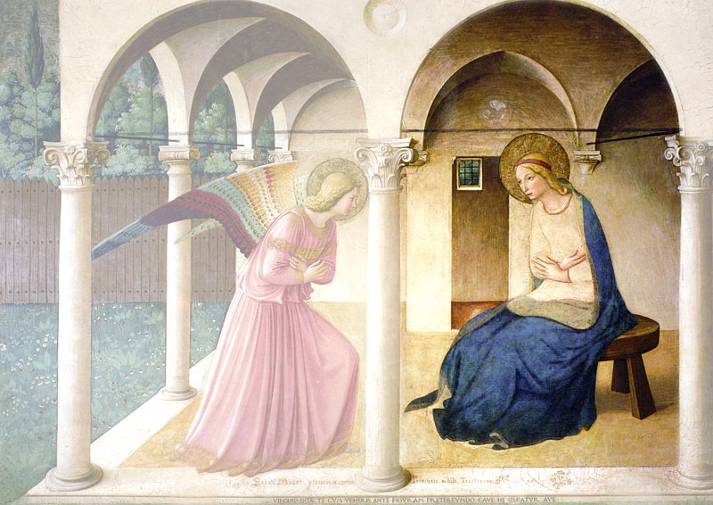

II. RELATION TO OUR CONFRERES

† The image “03-angelico-Marie-Mary.jpg” is projected.

Presentation
Animator:
Let us contemplate Mary as represented by Fra Angelico. She is the symbol of our community, because every Montfortian community should be the living presence of Mary in the Church and humankind. See how she is dressed simply. Her beauty and her wealth are inside her. See how her whole body, her whole self are in earnest of welcoming the Word that will guide her life and make her the dwelling place of God.

Lineamenta
We have been called to live our relationship with God and with others within a community of brothers. Our very first proclamation of the Gospel is our life as brothers. Being one family throughout the world, we share what we are and what we have.
We want to become a real family, where everyone feels welcomed and appreciated. Mutually enriched by our differences, we want our lives to unfold “in a charity that is attentive, full of good will (...) respect and patience” (RM 44). In a world hurt by violence, hatred and fear, we want to be prophets of a new world and build brotherhood without frontiers.

Animator: We will listen to an extract from the Taizé chant «Ubi caritas et amor, Deus ibi est»: where there is love and charity, God also is there» (available on montfortian.info) During that time, each one thinks of the members of his community and prays for them.

 Hymn

Ubi caritas et amor,
ubi caritas, Deus ibi est.

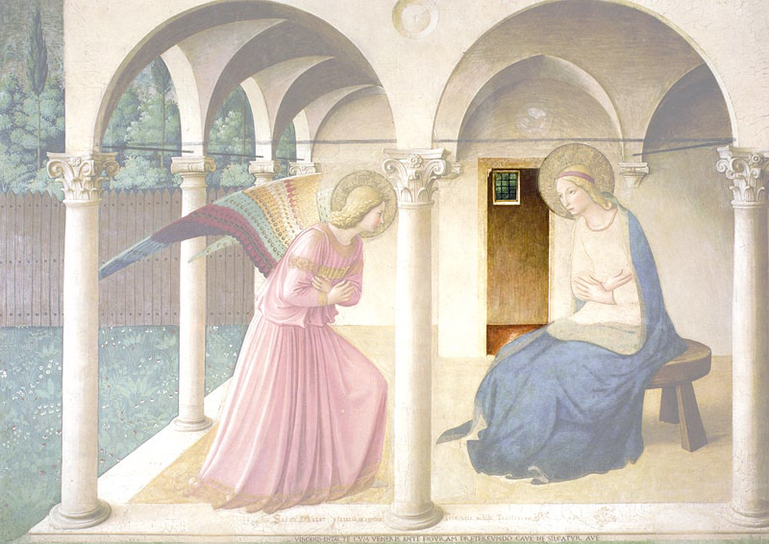

III. RELATION TO HUMANS

† The image “04-angelico-porte-door.jpg” is projected.

Presentation
Animator:
Fra Angelico placed a door at the left of the Virgin Mary. It can have two meanings. It can be the door to the nuptial room, where, according to medieval symbolism, Mary gives herself totally to God as his spouse. It can also be a door leading out of the house. In fact, the Gospel tells us that, right after the Annunciation, Mary «left with haste» to go visit her cousin Elizabeth. Mary is thus the first missionary. She brings to others the God that inhabits her. And the very first fruit of her mission is Joy!

The Word of God
From the first letter of Paul to the Corinthians (9: 16-23)
If I preach the gospel, there is nothing for me to boast about, for necessity is pressed upon me; yes, woe is me if I do not preach the gospel! For being free from all men, I have made myself a slave to all, in order that I might win the more; and to the Jews I became as a Jew, in order that I might win Jews; to the weak I became as weak, in order that I might win the weak. I have become all things to all men, that I might by all means save some. Now this I do for the sake of the gospel, in order that I may become a partaker of it with you.

Lineamenta
We want to share with humankind our most precious gift: our relationship with the Father through Christ. Before all, we are missionaries walking "in the footsteps of the poor Apostles" (RM 2), aiming at "renewing the spirit of Christianity" (RM 56) through an ardent word and "a tender and true devotion to the Holy Virgin" (LEW 203).
“Lord, what am I asking you for? Liberos: missionaries as free as you are, detached from everything (...) who will range far and wide, with the burning and bright flame of the Gospel in their mouth (...) to burn like fire and bring light into the darkness of the world, like the sun (PE 7. 12). – Prayer and mission will always be united in our daily life.

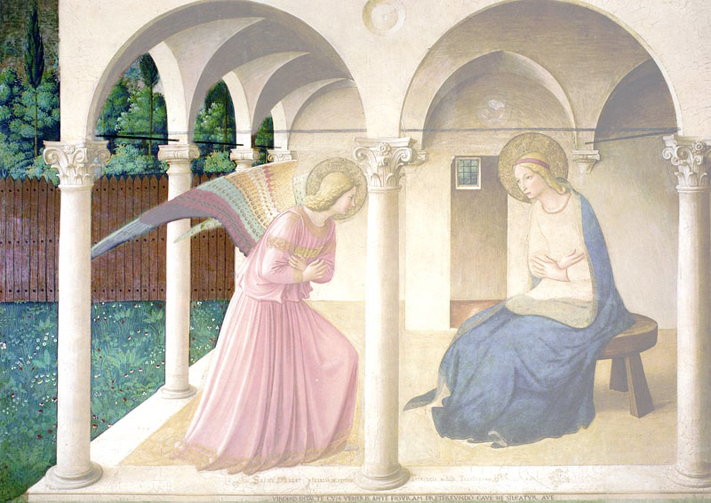

IV. RELATION TO CREATION

† The image “05-angelico-nature.jpg” is projected.

Presentation
Animator:
To the left of the angel, nature appears! In the foreground, we see nature marked by man: it’s the well-tended garden. Behind the fence, a dense forest is shown. But it is not pure disorder. A path can be seen, barely indicated by high cypress trees. This points out that nature is in search of its meaning, of a road. As saint Paul said: «The anxious longing of the creation waits eagerly for the revealing of the sons of God. For the creation was subjected to futility, not willingly, but because of Him who subjected it, in hope that the creation itself also will be set free from its slavery to corruption into the freedom of the glory of the children of God.» (Romans 8: 19-21)

Lineamenta
More and more aware of the beauty but also of the fragility of Creation, we want to admire and protect it, both as citizens and bearers of the Good News. We are tempted by wasting and over consumption.
As members of the Diakonia-Church, we see ourselves as “servants of a New Covenant” (2 Cor 3:16) between God and humankind and between God and the world.
Through our vow of poverty, we want to commit ourselves to a simple lifestyle and the sharing of our resources, aware that what we own is intended for the mission and for the poor. We will change our perception of creation by refusing to see it purely as resources to be exploited. We will discover it as a gift from God, offered to all of humanity and trusted to our care.

Final prayer
† The image “06-angelico-complet-complete.jpg” is projected.

Animator: We end our celebration by praying the Angelus and renewing our consecration.

The angel came to Mary and said: “Rejoice, Full of grace, the Lord is with you.
ALL: You will conceive and bear a son, who will be the Son of God.” (Luke 1, 28.31.35)
 Ave, ave, ave Maria.

Mary said to the angel: “Behold, the servant of the Lord.
ALL: May it be done to me according to your word.” (Luke 1: 38)
 Ave, ave, ave Maria.

And the Word became flesh,
ALL: and dwelt among us. (John 1: 14)
 Ave, ave, ave Maria.

To those who received him,
ALL: he gave power to become children of God. (John 1: 12)
 Ave, ave, ave Maria.

Brief formula of Consecration (ASE 223-227)

Most lovable and adorable Jesus!
Eternal Wisdom within the Father,
Incarnate Wisdom in the womb of Mary.

I thank you for assuming the condition of slave
to set me free from the slavery of Evil.

Since I was not faithful to the promises of my baptism,
I do not deserve to be called your slave.

That is why I turn to the intercession of your holy Mother.
Therefore, I greet you O Mary, refuge of sinners.

Grant my desire for divine Wisdom
and accept the offering of myself
which I now make to you.

I, N. ………….., unfaithful sinner,
renew through you to-day my baptismal promises.
I give myself completely to Jesus Christ
to carry my cross in his footsteps for the rest of my life.

To be more faithful to him from now on,
I choose you to-day as my mother and my queen.

I consecrate to you all that I am and that I have:
my body, my soul, my spiritual and material belongings.
I give you the full right to dispose of me
for the greater glory of God.

Virgin most faithful, make me in all things
such a perfect disciple,
imitator and slave of Wisdom Incarnate,
Jesus Christ your Son,
that, through your intercession and in your likeness,
I may mature to the fulness of his age on earth
and of his glory in heaven.
AMEN

Concluding Hymn
† The entrance hymn can be sung again.

