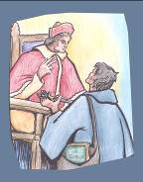
12. EVENT: Pilgrimage to Rome, and meeting with Clement XI.
● Date : 6 June 1706
● Place : Rome, the Vatican
● Value : Belonging to the Church; commitment to work for its renewal.
● The Story :
The first five years of Louis Marie’s ministry put his apostolic zeal and his creativity to a severe test. He was hesitating between a far-off mission or a mission in his own country. He decided to make a pilgrimage to Rome to meet with the Holy Father. In response to his own call, and conscious of the mission he had received from God, Louis Marie would ask to be sent into the Church by the Church itself. Having asked, among others, the people of Montbernage (Poitiers) and Mathurin, to accompany him in their prayers, he left on foot, going by way of the Marian shrine in Loreto, to meet Clement XI, who received him in audience on 6 June 1706.
Montfort believed he was seeing Jesus Christ himself in the person of his Vicar on earth. He set forth his motives for coming, summarising in a few words his history, his ardent desires, and his availability.
Clement XI showed himself in a paternal light. He questioned Louis Marie, allowing him to speak at length of his Marian devotion, the pattern he used in his mission, his plans for foundations. And at the same time, he thought of the dioceses of France, that difficult territory which the Gallican trend was dividing from Rome and whose faith and fidelity Jansenism was eroding.
Finally, the Pope said to him: “You have a wide enough field in France, Monsieur, for the exercise of your zeal; do not go elsewhere, and always work in perfect submission to the bishops in the dioceses to which you will be called: by this means, God will bestow blessings on your labours.” He conferred on Louis Marie the title of “apostolic missionary”. Then, very willingly, he blessed a small ivory crucifix that he presented to him, and that Louis Marie would fix to the top of his pilgrim’s staff. Montfort would carry out to the letter the words of Clement XI, and would make his whole life an act of obedience to the mission confided to him by the Pope. His pilgrimage to Rome allowed him to see his intuitions confirmed, as well as his desires to respond in his own way to the urgent needs of the Church, that he had already expressed very clearly from the first months of his priesthood (cf. Letter 5).
● From Montfort’s Writings: (Prayer for Missionaries, 17)
When will it happen, this fiery deluge of pure love with which you are to set the whole world ablaze and which is to come, so gently yet so forcefully, that all nations,(...) will be caught up in its flames and be converted? None can shield himself from the heat it gives (Ps 19:17), so let its flames rise (Is 62:1). Rather let this divine fire which Jesus Christ came to bring on earth be enkindled before the all-consuming fire of your anger comes down and reduces the whole world to ashes. Send out your breath and life begins; you renew the face of the earth (Ps. 104, 30). Send this all-consuming Spirit upon the earth to create priests who burn with this same fire and whose ministry will renew the face of the earth and reform your Church.
● Light from the Bible: (1 Corinthians 1:19-25)
As scripture says: I am going to destroy the wisdom of the wise and bring to nothing the understanding of any who understand. Where are the philosophers? Where are the experts? And where are the debaters of this age? Do you not see how God has shown up human wisdom as folly? Since in the wisdom of God the world was unable to recognise God through wisdom, it was God's own pleasure to save believers through the folly of the gospel. While the Jews demand miracles and the Greeks look for wisdom, we are preaching a crucified Christ: to the Jews an obstacle they cannot get over, to the gentiles foolishness, but to those who have been called, whether they are Jews or Greeks, a Christ who is both the power of God and the wisdom of God. God's folly is wiser than human wisdom, and God's weakness is stronger than human strength.
(Romans 10:13-15)
All who call on the name of the Lord will be saved. How then are they to call on him if they have not come to believe in him? And how can they believe in him if they have never heard of him? And how will they hear of him unless there is a preacher for them? And how will there be preachers if they are not sent? As scripture says: How beautiful are the feet of the messenger of good news.

● Personal integration/sharing
- Montfort prayed that “the Church might be reformed”. In what special ways does my Church need to be reformed?
- What precise challenge does Pope Francis address to us, the Montfortian family, today?
- What might being an “apostolic missionary” mean today?
- What is one urgent need of the Church to which we are called to respond.
● Prayer/Celebration
- Holy Spirit, enkindle in us the fire of the Gospel.
Come, Holy Spirit, into our hearts.
- Holy Spirit, make us all good servants of your Church.
Come, Holy Spirit, into our hearts.
- Holy Spirit, make us love the Church as Christ loved her and laid down his life for her.
Come, Holy Spirit, into our hearts.
- Holy Spirit, renew in us the joy of our Baptism.
Come, Holy Spirit, into our hearts.
- Holy Spirit, lead us in the footsteps of Montfort.
Come, Holy Spirit, into our hearts.
- Holy Spirit, free us from fear when faced with the challenges of evangelisation.
Come, Holy Spirit, into our hearts.
● Symbol: A photo of Pope Francis
● Commitment:
- One cannot be a Christian alone. What can I do now to nourish and deepen my belonging to the local Church?
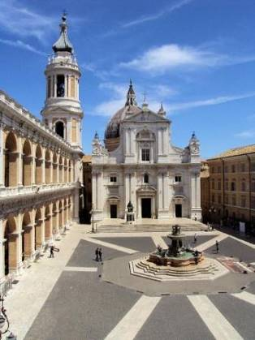
Loreto to-day

From Poitiers to Loreto to-day
